SIMATS ENGINEERING
ASSESSMENT TOOL 1
NAME: MONISHVARAN V
REG NO: 192424398
COURSE NAME: Database Management Systems
COURSE CODE: CSA0501

COURSE OUTCOME COVERED

CO1: Analyze DBMS architecture, different data models, schema types, and design ER/EER diagrams, relational schemas for case-based scenarios by identifying entities and relationships. (BL1, BL2)

Activity Tool : Short Answer Text(High)
Assessment Tool Weightage: 30%
Dr
QUESTIONS Total Marks: 50
Q.No | Question | Bloom's Level | Marks
1 | UPS Product Tracking Information System  UPS prides itself on having up-to-date information on the processing and current location of each shipped item. To do this, UPS relies on a company-wide information system. Shipped items are the heart of the UPS product tracking information system. Shipped items can be characterized by item number (unique), weight, dimensions, insurance amount, destination, and final delivery date. Shipped items are received into the UPS system at a single retail center. Retail centers are characterized by their type, uniqueID, and address. Shipped items make their way to their destination via one or more standard UPS transportation events (i.e., flights, truck deliveries). These transportation events are characterized by a unique scheduleNumber, a type (e.g, flight, truck), and a deliveryRoute. Create an Entity Relationship diagram that captures this information about the UPS system. | BL1 – Remember | 5
2 | Course Management System  Consider a university database for the scheduling of classrooms for final exams. This database could be modeled as the single entity set exam, with attributes course-name, section-number, room-number, and time. Alternatively, one or more additional entity sets could be defined, along with relationship sets to replace some of the attributes of the exam entity set, as  • course with attributes name, department, and c-number  • section with attributes s-number and enrollment, and dependent as a weak entity set on course  • room with attributes r-number, capacity, and building  Show an E-R diagram illustrating the use of all three additional entity sets listed. | BL2 – Understand | 5
3 | University Registrar’s Office Management System  A university registrar’s office maintains data about the following entities:  - courses, including number, title, credits, syllabus, and prerequisites;  - course offerings, including course number, year, semester, section number, instructor(s), timings, and classroom;  - students, including student-id, name, and program;  - instructors, including identification number, name, department, and title.  - Further, the enrollment of students in courses and grades awarded to students in each course they are enrolled for must be appropriately modeled.  Construct an E-R diagram for the registrar’s office. | BL2 – Understand | 5
4 | Hospital Management System  Construct an E-R diagram for a hospital with a set of patients and a set of medical doctors.  Associate with each patient a log of the various tests and examinations conducted. Construct appropriate tables for the above ER Diagram :  Patient(SS#, name, insurance)  Physician ( name, specialization)  Test-log( SS#, test-name, date, time)  Doctor-patient (physician-name, SS#)  Patient-history(SS#, test-name, date) | BL2 – Understand | 5
5 | Company Project Management System  Construct an ER Diagram for Company having following details :  Company organized into DEPARTMENT. Each department has unique name and a particular employee who manages the department. Start date for the manager is recorded. Department may have several locations.  • A department controls a number of PROJECT. Projects have a unique name, number and a single location.  • Company’s EMPLOYEE name, ssno, address, salary, sex and birth date are recorded. An employee is assigned to one department, but may work for several projects (not necessarily controlled by dept). Number of hours/week an employee works on each project is recorded; The immediate supervisor for the employee.  • Employee’s DEPENDENT are tracked for health insurance purposes (dependentname, birthdate, relationship to employee). | BL2 – Understand | 5
6 | Explain schema and instance with examples. Distinguish between logical schema, physical schema, and view schema. | BL1 – Remember | 5
7 | Identify the entities, attributes, and relationships for a Bank Management System and construct its ER diagram. | BL2 – Understand | 5
8 | Explain the Extended ER (EER) model. Describe the concepts of generalization, specialization, and aggregation. | BL2 – Understand | 5
9 | Design an EER diagram for a Hospital Management System incorporating inheritance and weak entities. | BL2 – Understand | 5
10 | Explain the role of a DBA (Database Administrator) and the responsibilities associated with the position. | BL1 – Remember | 5

Code of Conduct:

I MONISHVARAN V (192424398) (Name / Reg No) certify that this submission is my original work and that I have adhered to the guidelines specified for this assessment.
I understand that any violation of academic integrity rules will result in disciplinary action.

Signature of the student:
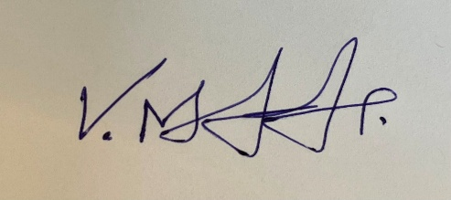

RUBRICS FOR CALCULATION:

Criteria | Weightage | Level 4 (Exemplary) | Level 3 (Proficient) | Level 2 (Developing) | Level 1 (Beginning)
Concept Identification | 30% | Demonstrates  clear and  complete  understanding of  the concept | Good  understanding  with minor  gaps | Basic  understanding  with some  misconceptions | Poor or  incorrect  understandin  g
Linkages | 25% | Completely  correct answer  with no errors | Mostly correct  with minor  errors | Partially correct  with noticeable  errors | Incorrect or  irrelevant  answer
Organization | 20% | Correctly applies  concepts to solve  the  question/problem | Applies  concepts with  minor  mistakes | Limited or  partially correct  application | No or  incorrect  application
Integration of Literature | 15% | Covers all  required parts of  the question | Covers most  parts with  minor  omissions | Covers only  some parts | Incomplete  or missing  response
Clarity | 10% | Clear, concise,  and well-  organized answer | Understandabl  e with minor  issues | Somewhat  unclear or poorly  structured | Difficult to  understand

- UPS Product Tracking Information System – ER Diagram (DBMS)
Entities and Attributes
1. SHIPPED_ITEM
Primary Key: Item_Number
Attributes:
- Item_Number (PK)
- Weight
- Dimensions
- Insurance_Amount
- Destination
- Final_Delivery_Date

2. RETAIL_CENTER
Primary Key: RetailCenter_ID
Attributes:
- RetailCenter_ID (PK)
- Type
- Address

3. TRANSPORTATION_EVENT
Primary Key: Schedule_Number
Attributes:
- Schedule_Number (PK)
- Type (Flight/Truck)
- Delivery_Route

Relationships
1. RECEIVED_AT
- Relationship: Retail Center receives Shipped Item
- Cardinality:
  - One Retail Center → Many Shipped Items (1:M)
  - Each shipped item is received at only one retail center.
RETAIL_CENTER (1) ─────< RECEIVED_AT >───── (M) SHIPPED_ITEM

2. TRANSPORTED_BY
- Relationship: Shipped Item is transported through Transportation Events
- Cardinality:
  - Many Shipped Items ↔ Many Transportation Events (M:N)
  - A shipped item can travel through one or more transportation events.
  - A transportation event can carry many shipped items.
SHIPPED_ITEM (M) ─────< TRANSPORTED_BY >───── (M) TRANSPORTATION_EVENT

ER Diagram (Text Representation)
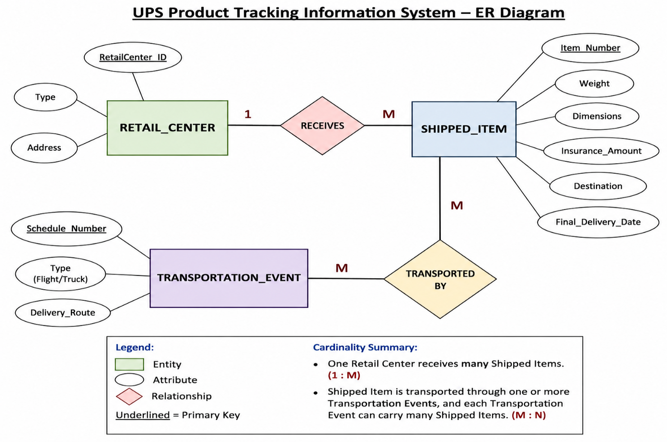

Cardinality Summary
Entity 1 | Relationship | Entity 2 | Cardinality
Retail Center | Receives | Shipped Item | 1 : M
Shipped Item | Transported By | Transportation Event | M : N

2.) Course Management System – Theory Answer (DBMS)
Answer:
The Course Management System is designed to schedule classrooms for final examinations in a university. Instead of representing all information in a single EXAM entity, the database is normalized by introducing separate entities for COURSE, SECTION, and ROOM. This reduces redundancy and improves data management.
Entities and Attributes
1. COURSE (Strong Entity)
- Primary Key: c-number
- Attributes:
  - c-number (PK)
  - Name
  - Department
2. SECTION (Weak Entity)
- Partial Key: s-number
- Attributes:
  - s-number (Partial Key)
  - Enrollment
Reason:
A section cannot exist without a course. Therefore, SECTION is modeled as a weak entity and depends on COURSE.
3. ROOM (Strong Entity)
- Primary Key: r-number
- Attributes:
  - r-number (PK)
  - Capacity
  - Building
4. EXAM (Relationship)
The exam scheduling information is represented through a relationship among COURSE, SECTION, and ROOM.
Attributes of Exam:
- Course-name
- Section-number
- Room-number
- Time

Relationships
1. COURSE — HAS — SECTION
- Cardinality: 1 : N
- One course can have many sections.
- Each section belongs to only one course.
2. SECTION — SCHEDULED_EXAM — ROOM
- Cardinality: M : N
- Many sections can be scheduled in many rooms.
- Each exam is conducted in one room at a specified time.

Cardinality
Entity | Relationship | Entity | Cardinality
COURSE | Has | SECTION | 1 : N
SECTION | Scheduled in | ROOM | M : N

Advantages of this Design
- Eliminates data redundancy.
- Maintains data integrity.
- Supports multiple sections for a course.
- Allows efficient scheduling of examination rooms.
- Makes the database easier to maintain and update.

Conclusion
The E-R model consists of three entity sets: COURSE, SECTION, and ROOM. The SECTION entity is modeled as a weak entity because it depends on the COURSE entity for identification. The SCHEDULED_EXAM relationship connects SECTION and ROOM and stores the examination time. This design efficiently represents the university's final examination scheduling system.
ER DAIGRAM:
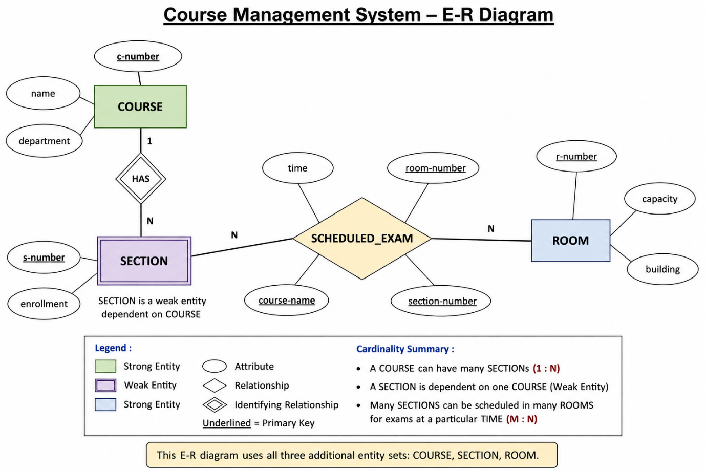

3.) Explanation of the ER Model
- Courses
  - Attributes: Course No, Title, Credits, Syllabus, Prerequisites
  - Relationship: Offered As → Course Offering
- Course Offering
  - Attributes: Year, Semester, Section No, Classroom, Timing
  - Relationship: Taught By → Instructor
- Instructors
  - Attributes: Instructor ID, Name, Department, Title
- Students
  - Attributes: Student ID, Name, Program
  - Relationship: Enrolled In → Course Offering
- Enrollment
  - Connects Students ↔ Course Offering
  - Attributes: Grade, Marks
This ER diagram models the registrar’s office system by capturing:
- Courses and their offerings per semester/year
- Instructors teaching specific offerings
- Students enrolling in offerings
- Grades awarded through the Enrollment relationship
ER DAIGRAM :

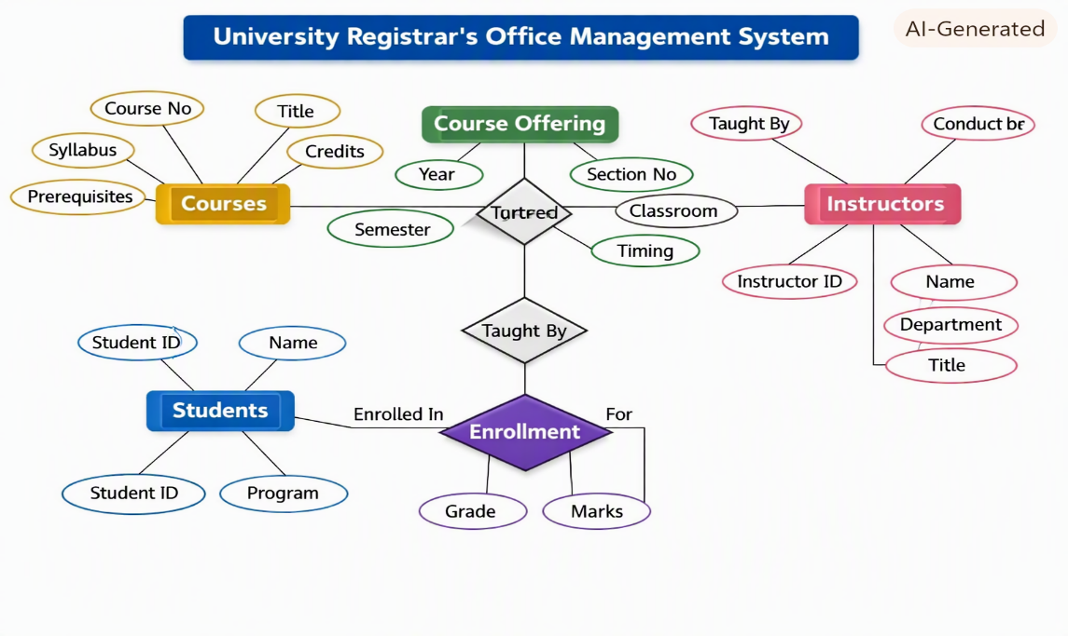
4.) Entities and Relationships
- Patient
  - Attributes: SS#, Name, Insurance
  - Relationship: Undergoes → Test Log
  - Relationship: Treated By → Physician
- Physician
  - Attributes: Name, Specialization
  - Relationship: Treated By → Patient
- Test Log
  - Attributes: SS#, Test Name, Date, Time
  - Relationship: Undergoes → Patient
- Doctor–Patient
  - Attributes: Physician Name, SS#
  - Relationship: Links → Physician ↔ Patient
- Patient History
  - Attributes: SS#, Test Name, Date
  - Relationship: Has History → Patient
📋 Corresponding Tables
Table Name | Attributes | Primary Key | Foreign Key
Patient | SS#, Name, Insurance | SS# | —
Physician | Name, Specialization | Name | —
Test_Log | SS#, Test_Name, Date, Time | (SS#, Test_Name, Date) | SS# → Patient
Doctor_Patient | Physician_Name, SS# | (Physician_Name, SS#) | Physician_Name → Physician, SS# → Patient
Patient_History | SS#, Test_Name, Date | (SS#, Test_Name, Date) | SS# → Patient

This model captures the hospital’s workflow:
- Each patient is treated by one or more physicians.
- Each test log records examinations for a patient.
- The doctor–patient table maintains treatment relationships.
- The patient history table keeps a chronological record of tests.
ER DAIGRAM:
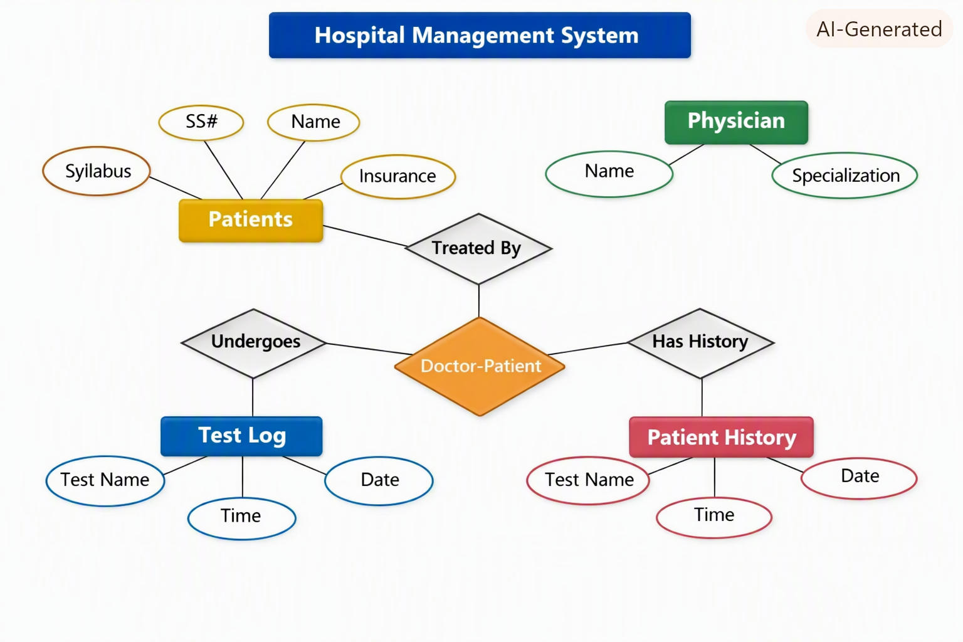
5.) Entities and Relationships
- Department
  - Attributes: Dept Name, Location, Manager Start Date
  - Relationship: Manages → Employee
  - Relationship: Controls → Project
- Project
  - Attributes: Project Name, Project Number, Project Location
  - Relationship: Controlled By → Department
  - Relationship: Worked On → Employee
- Employee
  - Attributes: SSN, Name, Address, Salary, Sex, Birth Date
  - Relationship: Assigned To → Department
  - Relationship: Works On → Project (with Hours/Week)
  - Relationship: Supervises → Employee (self-relation)
  - Relationship: Has Dependents → Dependent
- Dependent
  - Attributes: Dependent Name, Birth Date, Relationship
📋 Corresponding Tables
Table Name | Attributes | Primary Key | Foreign Key
Department | Dept_Name, Location, Manager_SSN, Manager_Start_Date | Dept_Name | Manager_SSN → Employee
Project | Proj_Name, Proj_Number, Proj_Location, Dept_Name | Proj_Number | Dept_Name → Department
Employee | SSN, Name, Address, Salary, Sex, Birth_Date, Dept_Name, Supervisor_SSN | SSN | Dept_Name → Department, Supervisor_SSN → Employee
Works_On | SSN, Proj_Number, Hours_Per_Week | (SSN, Proj_Number) | SSN → Employee, Proj_Number → Project
Dependent | SSN, Dep_Name, Birth_Date, Relationship | (SSN, Dep_Name) | SSN → Employee

This model captures the company’s organizational structure:
- Departments manage projects and have managers.
- Employees belong to departments, work on projects, and may supervise others.
- Dependents are linked to employees for insurance tracking.
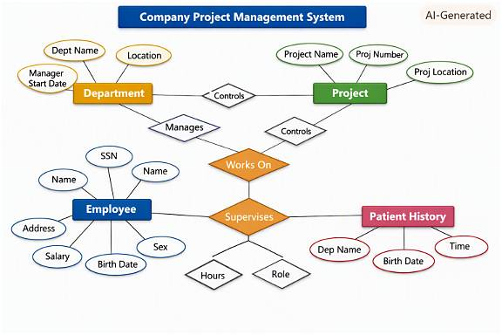
6.) Schema and Instance
Schema
- Definition: Schema is the structure or blueprint of a database. It defines how data is organized — the tables, fields, relationships, constraints, and data types.
- Example:
text
Student(SID, Name, Dept, Age)
This schema defines the structure of the Student table — what attributes exist and their types.
Instance
- Definition: Instance is the actual data stored in the database at a particular moment. It changes frequently as records are added, updated, or deleted.
- Example:
text
SID | Name | Dept | Age
101 | Arjun | CSE | 20
102 | Priya | ECE | 21
This is an instance of the Student table at a specific time.
🧠 Types of Schemas
Type | Description | Example
Logical Schema | Describes the logical design — tables, relationships, constraints, and data types. It focuses on how data is logically stored and connected. | Defines tables like Student, Course, Enrollment and their relationships.
Physical Schema | Describes the physical storage — how data is stored on disk, indexing, partitioning, and access paths. | Specifies file organization, indexes, and storage blocks for the Student table.
View Schema | Defines user views — subsets or virtual tables derived from the logical schema for specific users or applications. | A view showing only Name and Dept from Student for faculty access.
🧾 Summary
- Schema → Database design (structure).
- Instance → Actual data at a given time.
- Logical Schema → Conceptual design.
- Physical Schema → Storage-level design.
- View Schema → Customized user-level view.

7.) 🏦 Entities and Attributes
Entity | Attributes | Description
Customer | Customer_ID, Name, Address, Phone, Email | Represents people who hold accounts or take loans.
Account | Account_No, Type, Balance, Open_Date | Each customer can have one or more accounts.
Loan | Loan_ID, Amount, Type, Issue_Date, Interest_Rate | Represents loans taken by customers.
Branch | Branch_ID, Branch_Name, Location | Represents different branches of the bank.
Employee | Emp_ID, Name, Position, Salary | Represents staff working in branches.
Transaction | Trans_ID, Date, Amount, Type (Deposit/Withdrawal), Account_No | Records all account transactions.
🔗 Relationships
Relationship | Connected Entities | Description
Owns | Customer ↔ Account | A customer owns one or more accounts.
Applies_For | Customer ↔ Loan | A customer can apply for multiple loans.
Operates | Employee ↔ Account | Employees manage or operate customer accounts.
Works_In | Employee ↔ Branch | Each employee works in one branch.
Located_At | Branch ↔ Account | Accounts are maintained at a specific branch.
Performs | Account ↔ Transaction | Transactions are performed on accounts.
🧩 ER Diagram Structure
The ER diagram (as shown in the image) includes:
- Entities: Customer, Account, Loan, Branch, Employee, Transaction
- Relationships: Owns, Applies_For, Operates, Works_In, Located_At, Performs
- Cardinalities:
  - One Customer → Many Accounts
  - One Account → Many Transactions
  - One Branch → Many Employees
  - One Employee → Many Accounts
📋 Example Tables

Table | Attributes | Primary Key | Foreign Key
Customer | Customer_ID, Name, Address, Phone, Email | Customer_ID | —
Account | Account_No, Type, Balance, Open_Date, Customer_ID, Branch_ID | Account_No | Customer_ID → Customer, Branch_ID → Branch
Loan | Loan_ID, Amount, Type, Issue_Date, Interest_Rate, Customer_ID | Loan_ID | Customer_ID → Customer
Branch | Branch_ID, Branch_Name, Location | Branch_ID | —
Employee | Emp_ID, Name, Position, Salary, Branch_ID | Emp_ID | Branch_ID → Branch
Transaction | Trans_ID, Date, Amount, Type, Account_No | Trans_ID | Account_No → Account

8.) Extended ER (EER) Model
The EER model is an enhancement of the traditional Entity–Relationship (ER) model. It introduces advanced concepts to represent more complex relationships and constraints in real-world applications.
It extends ER with:
- Generalization
- Specialization
- Aggregation
🔑 Concepts
1. Generalization
- Definition: A process of abstracting common features from multiple entities and creating a higher-level, generalized entity.
- Example:
  - Entities: Car, Bike, Truck
  - Generalized Entity: Vehicle (with common attributes like Registration_No, Owner, Model).
- Use: Reduces redundancy by grouping shared attributes.
2. Specialization
- Definition: The opposite of generalization. It creates subclasses of an entity based on distinguishing characteristics.
- Example:
  - Entity: Employee
  - Specialized Entities: Manager, Engineer, Clerk
  - Each subclass has specific attributes (e.g., Manager → Bonus, Engineer → Skill).
- Use: Adds detail by differentiating entities.
3. Aggregation
- Definition: A higher-level abstraction where a relationship itself is treated as an entity.
- Example:
  - Relationship: Works_On between Employee and Project
  - Aggregation: Assignment entity that represents the relationship, with attributes like Hours_Per_Week.
- Use: Useful when relationships need attributes or when relationships participate in other relationships.
📊 Summary Table
Concept | Direction | Purpose | Example
Generalization | Bottom → Top | Combine common features | Car, Bike → Vehicle
Specialization | Top → Bottom | Create subclasses | Employee → Manager, Engineer
Aggregation | Relationship → Entity | Treat relationship as entity | Works_On → Assignment

9.) Entities and Attributes
- Hospital
  - Attributes: Hospital_ID, Name, Location
- Person (Superclass)
  - Attributes: Person_ID, Name, Address, Contact
  - Inheritance: Specialized into Doctor, Patient, Nurse, Staff
- Doctor (Subclass of Person)
  - Attributes: Specialization, Salary
- Patient (Subclass of Person)
  - Attributes: Patient_ID, Disease, Admission_Date
- Nurse (Subclass of Person)
  - Attributes: Duty_Shift
- Staff (Subclass of Person)
  - Attributes: Role
- Treatment (Weak Entity)
  - Attributes: Treatment_ID, Description, Date
  - Dependent on Patient (identified by Patient_ID + Treatment_ID)
- Prescription (Weak Entity)
  - Attributes: Prescription_ID, Medicine_Name, Dosage
  - Dependent on Treatment
- Room
  - Attributes: Room_No, Type, Capacity
- Appointment
  - Attributes: Appointment_ID, Date, Time
  - Relationship: Patient ↔ Doctor
🔗 Relationships
- Admitted_In → Patient ↔ Room
- Treats → Doctor ↔ Patient
- Has_Treatment → Patient ↔ Treatment (weak entity)
- Has_Prescription → Treatment ↔ Prescription (weak entity)
- Schedules → Doctor ↔ Appointment ↔ Patient
📊 Key EER Concepts Used
- Inheritance (Specialization):
  - Person generalized into Doctor, Patient, Nurse, Staff.
- Weak Entities:
  - Treatment depends on Patient.
  - Prescription depends on Treatment.

10.) 🎯 Role of a DBA
A Database Administrator (DBA) is responsible for the installation, configuration, maintenance, and security of a database system. They ensure that data is available, consistent, secure, and efficiently managed for users and applications.
🛠️ Key Responsibilities of a DBA
1. Database Design & Implementation
- Define database schemas, tables, indexes, and relationships.
- Ensure normalization and efficient data modeling.
2. Installation & Configuration
- Install database software (e.g., Oracle, MySQL, SQL Server).
- Configure parameters for optimal performance.
3. Performance Monitoring & Optimization
- Monitor query performance and system load.
- Use indexing, partitioning, and tuning techniques to improve speed.
4. Backup & Recovery
- Schedule regular backups.
- Implement disaster recovery plans to restore data in case of failure.
5. Security Management
- Control user access with roles and privileges.
- Protect against unauthorized access and SQL injection attacks.
6. Data Integrity & Consistency
- Enforce constraints (primary keys, foreign keys).
- Ensure ACID properties (Atomicity, Consistency, Isolation, Durability).
7. User Support & Maintenance
- Assist developers and analysts with queries.
- Apply patches and upgrades to keep systems up-to-date.
8. Capacity Planning
- Forecast future storage and performance needs.
- Scale databases as the organization grows.
📊 Example Scenario
- In a hospital system, the DBA ensures that patient records are always available, secure, and recoverable in case of system crashes.
- In a banking system, the DBA guarantees transaction consistency and prevents unauthorized access to customer accounts.

